# Mobile Doctor

**Nur-E-Alam Jony Student ID: 20141201039**

### Department of Computer Science and Engineering

**Bangabandhu Sheikh Mujibur Rahman Science and Technology University, Gopalganj, Bangladesh**

**Mobile Doctor**

**Nur-E-Alam Jony Student ID: 20141201039**

**Department of Computer Science and Engineering**

**Bangabandhu Sheikh Mujibur Rahman Science and Technology University, Gopalganj, Bangladesh**

**Mobile Doctor**

**by**

**Nur-E-Alam Jony Student ID:20141201039**

**Supervised by**

**Saleh Ahmed**

**Submitted to the Department of Computer Science and**

**Engineering of Bangabandhu Sheikh Mujibur Rahman Science and Technology University in partial fulfillment of the**

**requirements for the degree of B.Sc. Engineering**

**Project Evaluation Committee:**

**Teacher Name 1** *. . . . . . . . . . . . . . . . . . . . . . . . . . . . . . . . . .*

**Teacher Name 2** *. . . . . . . . . . . . . . . . . . . . . . . . . . . . . . . . .*

**Teacher Name 3** *. . . . . . . . . . . . . . . . . . . . . . . . . . . . . . . . . .*

**Project Approval**

Student’s Name:Nur-E-Alam Jony Student’s ID:20141201039

Project Title: :Mobile Doctor

We the undersigned, recommend that the project completed by the student listed above, in partial fulfillment of B.Sc. Engineering degree requirements, be accepted by the Department of Computer Science and Engineering, Bangabandhu Sheikh Mujibur Rahman Science and Technology for deposit.

### Supervisor Approval*

.............................

Name of Supervisor:Saleh Ahmed Designation of Supervisor:Asst.Professor

**Additional Approvals ( if requires)\***

.............................

Name of Supervisor:Saleh Ahmed Designation of Supervisor:Asst.Professor

**Departmental Approval**

.............................

Name of Head of the Department:Saleh Ahmed Chairman, Department of Computer Science and Engineering

**Bangabandhu Sheikh Mujibur Rahman Science and Technology University, Gopalganj, Bangladesh**

***Dedicated to my parents, Md.Mokter Hossain And***

***Khaleda Akter***

**Abstract**

**Mobile Doctor** is a **health application**.User can store their daily health data and view them when they need.Simple diseases are also diagnosed here.Drugs index gives description of medicine.Tips bring awareness.The whole system is designed such a way that anyone can access it.

**Keywords:**Conditional logic,array,loop,string operation,functions,file opera- tion,structure,graphics function.

# Acknowledgment

I am very much thankful to the almighty Allah for giving me the opportunity to complete the project successfully. Then I am also thankful to my supervisor,Saleh Ahmed for allowing my idea of this project. For his supervision,I have been able to do such project.

I would like to express my heartfelt thanks to all of my friends for inspiring and supporting me to make the project success.

Nur-E-Alam Jony April,2016

# Table of Contents

|  |  |
| --- | --- |
| **Abstract** | **i** |
| **Acknowledgment** | **ii** |
| **Chapter 1 Introduction** | **1** |
| **Chapter 2 Related Works** | **2** |
| **Chapter 3 Implementation Details** | **3** |
| **Chapter 4 User Manual** | **5** |
| **Chapter 5 Limitations and Future Work** | **11** |
| **Chapter 6 Discussion** | **12** |
| **Bibliography** | **13** |
| **Appendix A List of Publications** | **15** |

**List of Figures**

4.1 Front Page . . . . . . . . . . . . . . . . . . . . . . . . . . . . . . . . 5

4.2 New account creation . . . . . . . . . . . . . . . . . . . . . . . . . . 6

4.3 Log in page . . . . . . . . . . . . . . . . . . . . . . . . . . . . . . . . 6

4.4 Home page . . . . . . . . . . . . . . . . . . . . . . . . . . . . . . . . 7

4.5 Data input . . . . . . . . . . . . . . . . . . . . . . . . . . . . . . . . 7

4.6 Calender-wise view . . . . . . . . . . . . . . . . . . . . . . . . . . . . 8

4.7 Graphical view . . . . . . . . . . . . . . . . . . . . . . . . . . . . . . 8

4.8 Diagnose Part:Diseases . . . . . . . . . . . . . . . . . . . . . . . . . . 8

* 1. Diagnose Part-Symptoms choose . . . . . . . . . . . . . . . . . . . . 9
  2. Diagnose Part-Input test data and showing result . . . . . . . . . . . 9 4.11 Drugs index 10

4.12 Tic-Tac-Toe game 10

# List of Tables

**List of Algorithms**

**Introduction**

People are very busy with their regular work.They have no time to take care of their health fitness. So,for keeping their regular health data such as weight,sugar level,body temperature and blood pressure,Mobile Doctor is helpful to them.It is useful for getting a total overview of their health.It also makes the users conscious about their body fitness.There are accounts for each users.They can store their data in their individual account and access them later. It also diagnoses diseases such as fever, diarrhea, diabetic and blood pressure.It is cost free and easy to access.

# Related Works

There are many apps on health and fitness(Fit-tracker,Mind and Brain,Fitness Meter etc.). These apps are diﬀerent categories. Some apps are on health tips,some are on drugs index, some apps store data , some are used to chat with doctor and so on.

# Implementation Details

I have used basic C Programming language with the header file graphics.h of C++ for graphics design. First user have to **create a new account**. In time of cre- ating a new account user have to input user name and password with other in- formation.Then four(4) text documents are created for individual user.(1.For pro- file,2.For store weight data,3.For store sugar level data,4.For store blood pressure data).The profile text document is named with user name and password.In time of **log in** user have to input his/her user name and password that s/he used in time of creation account.It combines password and user name and then matches with the profile text documents.If it matches,then the profile open.In **Home Page** there are **Weight Chart**,**Sugar level chart**,**Body temperature chart**,**Blood pressure chart**,**Diagnose**,**Drugs index**,**Refreshment**,**Proftle** and **Log out** op- tions.In each chart,there are two options,1.For **data adding** and 2.For **showing**.In data adding part, user input **date**(day only) and **data**(weight/sugar level/body temperature/blood pressure).Then the data is saved with date in respective file that was created during account creation.In showing part,there are two options,one for **graphical view** and another for **calender view**. It reads data from file and show them in respective view.In **diagnose** part,user choose **symptoms** and input re- quired **test data**.Then it matches the symptoms and test data.After matching,it gives result.In **drugs index** part,user can see various drugs **brand** with their **con- tains**,**manufacturing company** and **prices**.These information are kept in speci- fied file.In **proftle** part,user can see his/her personal information.There are also kept a option for **refreshment**.Here user can play **Tic-Tac-Toe** game.For this,there are

3.0 4

a [3][3] matrix.It is **user vs. computer** game.User click mouse in one portion,then computer gives it’s move.Who makes first X-X-X(for user) or O-O-O(for computer) in any line or in any diagonal,will become winner.There are **tips** option,showing various tips according to weather and also shows health tips.And last option for **log out**.

## Chapter 4

**User Manual**

1. At first the front page will appear.User can choose log in and new account option.

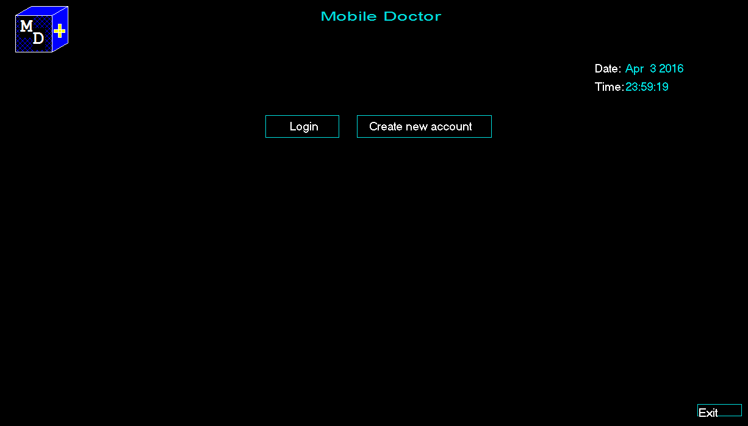

Figure 4.1: Front Page

1. If user have no previous account,s/he have to create new account.
2. If user have previous account,user can log in with user name and password. 4.After log in, the home page will appear.There user gets all options.
3. In every chart,there are two options(1.Adding data 2.View data).To add data user input date and data.
4. User can see the data of previous month in calender view. 7.Graphical view

8.Diagnose option 9.Symptoms choose

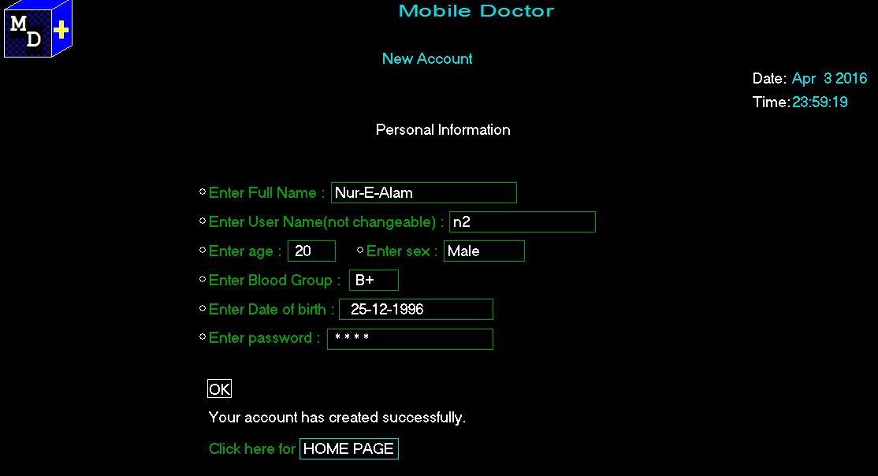

Figure 4.2: New account creation

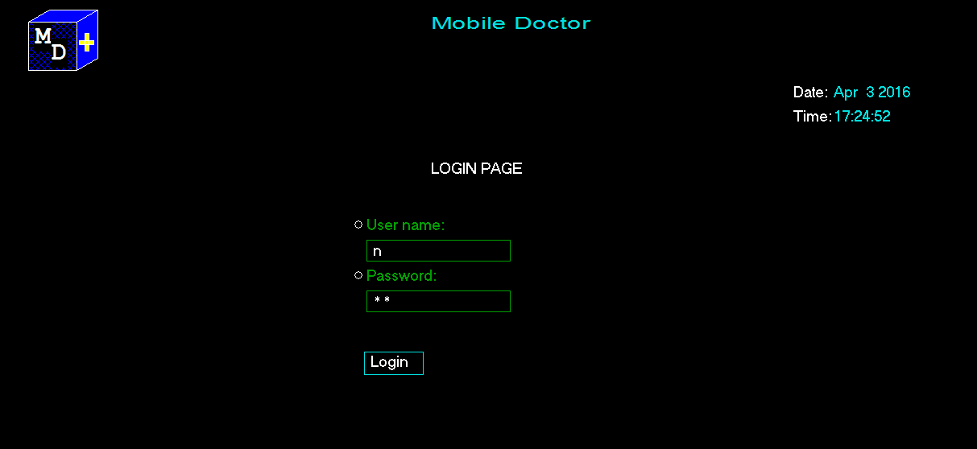

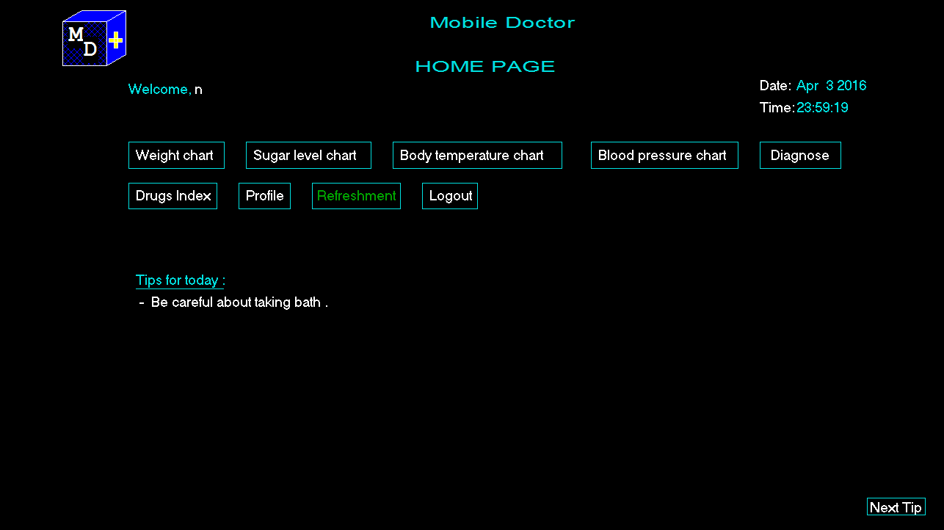

Figure 4.4: Home page

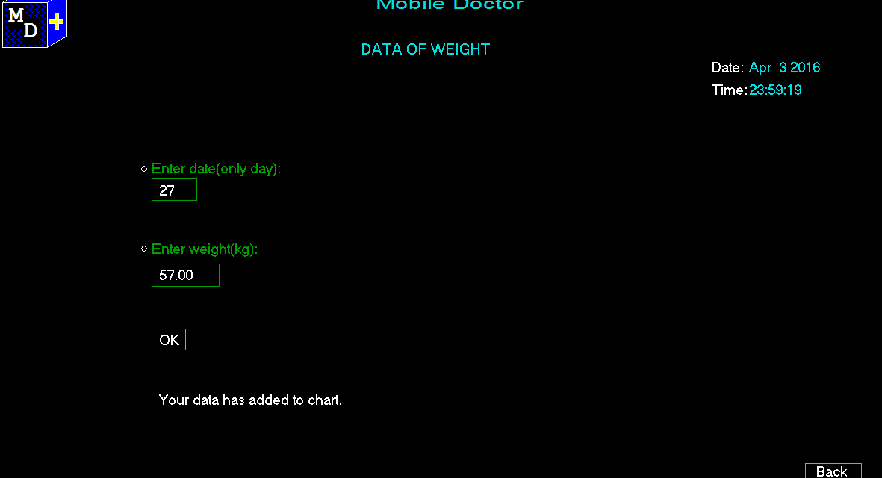

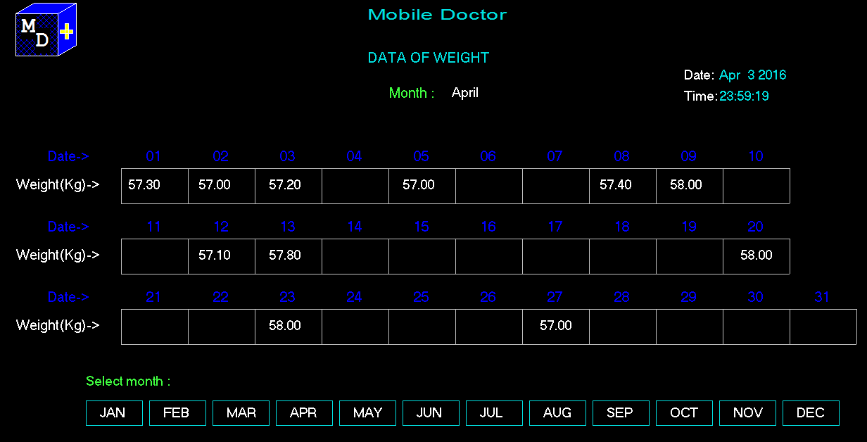

Figure 4.6: Calender-wise view

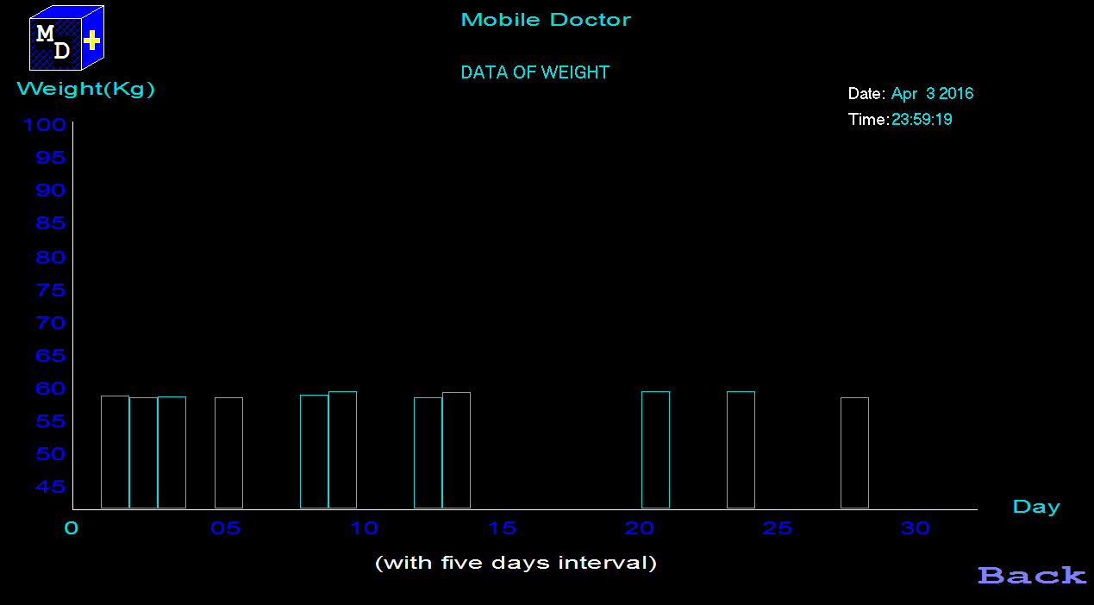

Figure 4.7: Graphical view

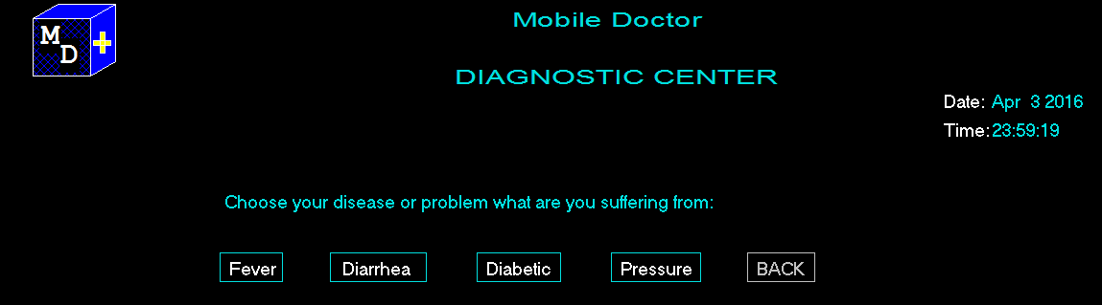

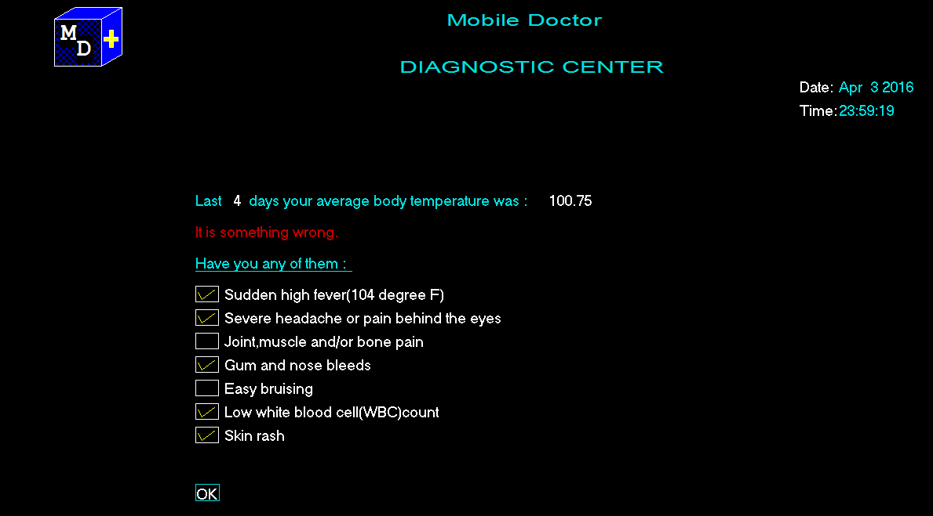

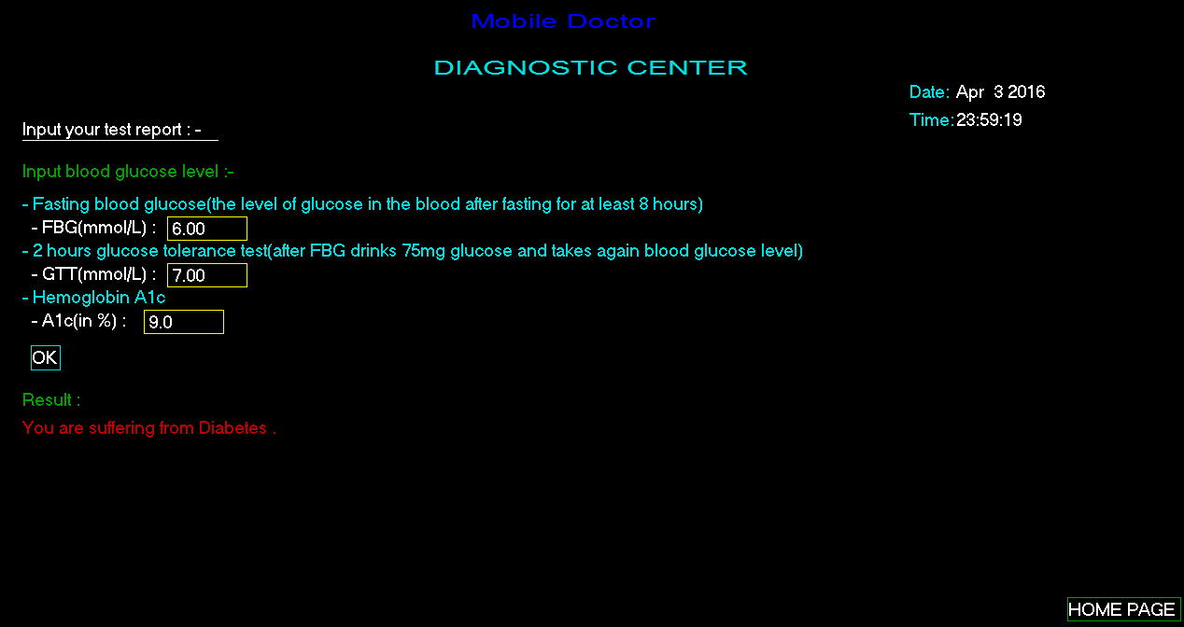Figure 4.9: Diagnose Part-Symptoms choose 10.Input test datd and showing result

Figure 4.10: Diagnose Part-Input test data and showing result 11.Drugs Index

1. Refreshment:Tic-Tac-Toe game,it user vs. computer game

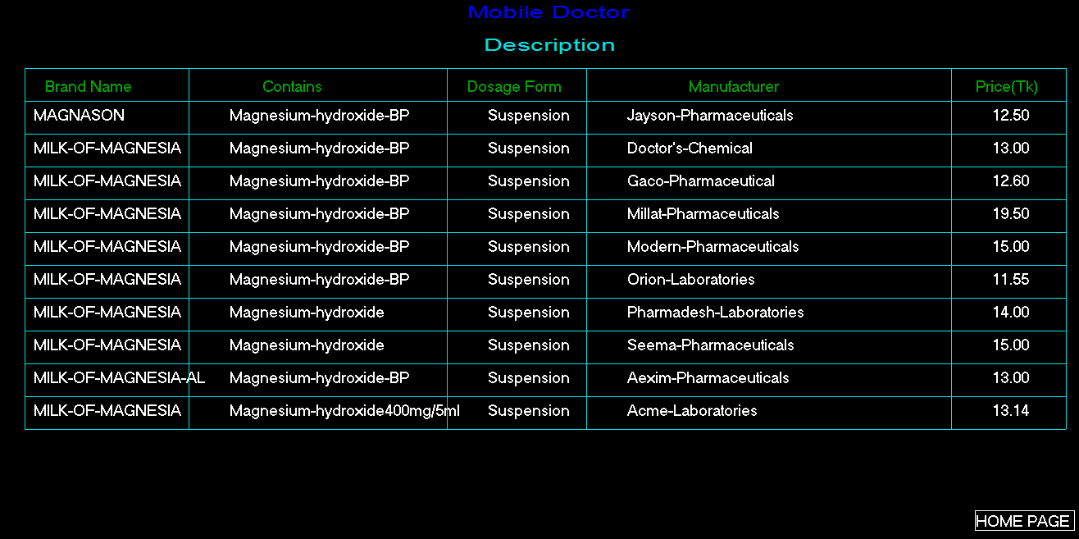

Figure 4.11: Drugs index

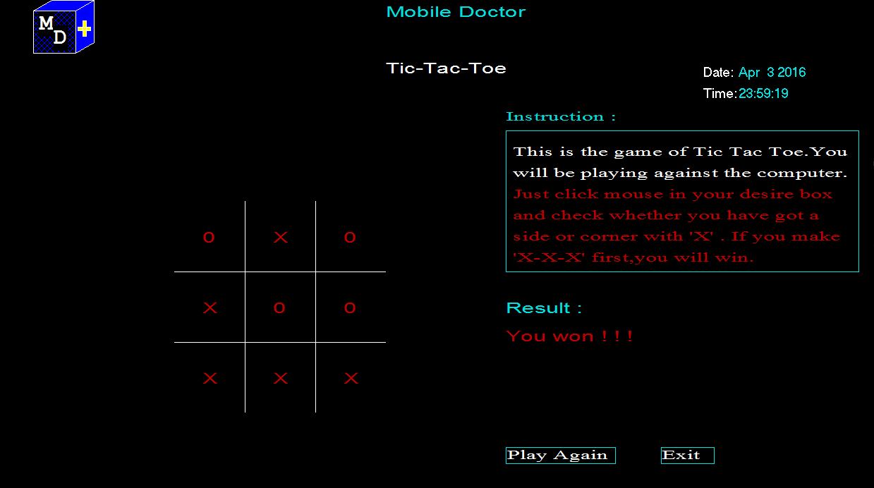

Figure 4.12: Tic-Tac-Toe game

# Limitations and Future Work

It is very sensitive for diagnosing diseases.The data vary from region to region,age to age,person to person.So,it can not give proper result.In future for developing this,I will work with doctors and analyze more test datas for getting more accurate result.I will also add a option for analyzing user health data and it will also suggest user what food or exercise s/he take should.

# Discussion

This project will be useful and helpful for general people.It grows awareness among them about their health fitness.Simple diseases can be diagnosed without any cost.I will develop it more to get more accurate result.

13

# Bibliography

## Appendix A

**List of Publications**

**International Journal Papers**

* 1. **Sajal Halder**, Yongkoo Han, A. M. Jehad Sarkar and Young-Koo Lee. An Entertainment Recommendation System using the Dynamics of User Behavior over Time. Decision in process in the Journal of Systems and Software.
  2. Md. Rezaul Karim, **Sajal Halder** , Byeong-Soo Jeong, and Ho-Jin Choi. Eﬃcient Mining Frequently Correlated, Associated-correlated and Independent Patterns Synchronously by Removing Null Transactions. Human Centric Tech- nology and Service in Smart Space, pages 93-103, 2012.
  3. **Sajal Halder**, A. M. Jehad Sarkar and Young-Koo Lee. A synthetic trajectory-based moving objects generator. Under review in International Jour- nal of Artificial Intelligence Tools.
  4. **Sajal Halder**, Md. Mostofa Kamal Rasel, Yongkoo Han, and Young-Koo Lee. Mining Spatiotemporal Moving Objects Swarm. Under review in Kyung Hee University Journal..

LIST OF PUBLICATIONS 16

## International Conference Papers

* 1. Sajal Halder, Yongkoo Han and Young-Koo Lee. Discovering Periodic Pat- terns using Supergraph in Dynamic Networks. Accepted in 5th International Conference on Data Mining and Intelligent Information Technology Applica- tions (ICMIA),Jun 18-20, South Korea, 2013.
  2. Sajal Halder, A. M. Jehad Sarkar and Young-Koo Lee. Movie Recommendation System Based on Movie Swarm. Second International Conference on Cloud and Green Computing (CGC), China, Nov 1-3, 2012.
  3. Sajal Halder, Md. Samiullah, A. M. Jehad Sarkar and Young-Koo Lee. MovieSwarm: Information Mining technique for Movie Recommendation Sys- tem. In the 7th International Conference on Electrical and Computer Engi- neering (ICECE), Bangladesh, Dec 20-22, 2012.

## Thesis/Project Works

* 1. Sajal Halder, Uzzal Kumar Dutta, Uttam Kumer Biswas and Asish Kumar Biswas “Classification of Multiple Protein Sequences by means of Irredundant Patterns”, B.Sc. Final Year Project, Department of Computer Science and Engineering (CSE), University of Dhaka (DU), Bangladesh, February, 2011.